$ ssh -i webappserver.pem ec2-user@18.209.159.131

A newer release of "Amazon Linux" is available.
Version 2023.11.20260511:
Run "/usr/bin/dnf check-release-update" for full release and version update info
Last login: Wed May 13 09:41:38 2026 from 103.160.27.197
[ec2-user@ip-172-31-40-141 ~]$ ls
[ec2-user@ip-172-31-40-141 ~]$ sudo -
sudo: -: command not found
[ec2-user@ip-172-31-40-141 ~]$ sudo su
[root@ip-172-31-40-141 ec2-user]# vi test
[root@ip-172-31-40-141 ec2-user]# ll
total 4
-rw-r--r--. 1 root root 23 May 14 18:59 test
[root@ip-172-31-40-141 ec2-user]# chmod 777 test
[root@ip-172-31-40-141 ec2-user]# ./test
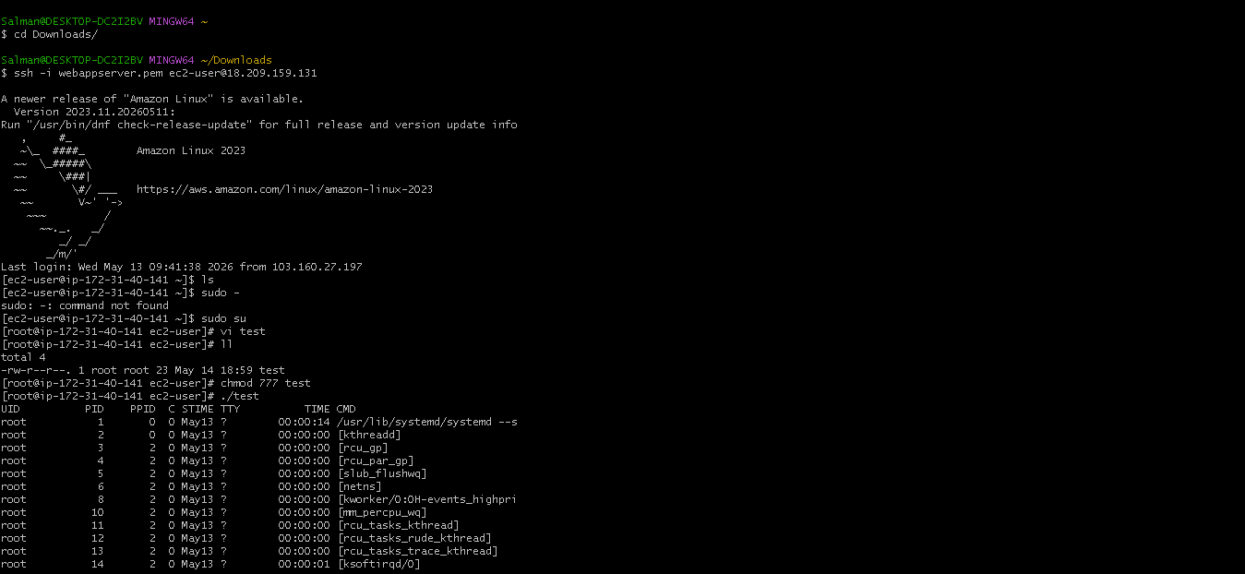
[root@ip-172-31-40-141 ec2-user]# pwd
/home/ec2-user
[root@ip-172-31-40-141 ec2-user]# mkdir -p /salman/scripts
[root@ip-172-31-40-141 ec2-user]# pwd
/home/ec2-user
[root@ip-172-31-40-141 ec2-user]# cd /salman/scripts
[root@ip-172-31-40-141 scripts]# ls
[root@ip-172-31-40-141 scripts]# vi helloworld
[root@ip-172-31-40-141 scripts]# ll
total 4
-rw-r--r--. 1 root root 31 May 14 19:11 helloworld
[root@ip-172-31-40-141 scripts]# chmod 777 helloworld
[root@ip-172-31-40-141 scripts]# ./helloworld
hello world
[root@ip-172-31-40-141 scripts]# pwd
/salman/scripts
[root@ip-172-31-40-141 scripts]# ll
total 4
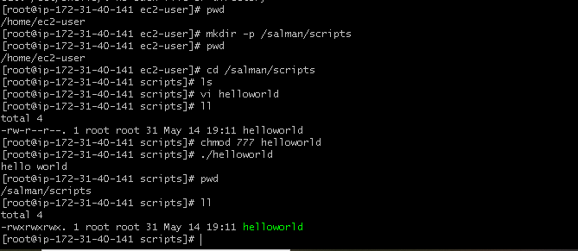
[root@ip-172-31-40-141 scripts]# vi abc
[root@ip-172-31-40-141 scripts]# ./abc
bash: ./abc: Permission denied
[root@ip-172-31-40-141 scripts]# bash abc.bash
bash: abc.bash: No such file or directory
[root@ip-172-31-40-141 scripts]# ls
abc helloworld.sh
[root@ip-172-31-40-141 scripts]# mv abc abc.bash
[root@ip-172-31-40-141 scripts]# chmod 755 abc.bash
[root@ip-172-31-40-141 scripts]# ./abc.bash
abc
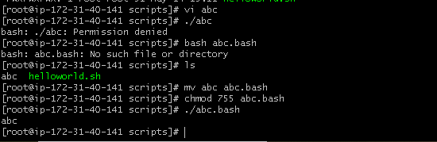

[root@ip-172-31-40-141 scripts]# vi helloworld.bash
[root@ip-172-31-40-141 scripts]# ll
total 12
-rwxr-xr-x. 1 root root 23 May 14 19:21 abc.bash
-rw-r--r--. 1 root root 110 May 14 19:31 helloworld.bash
-rwxrwxrwx. 1 root root 31 May 14 19:11 helloworld.sh
[root@ip-172-31-40-141 scripts]# ./helooworld.bash
bash: ./helooworld.bash: No such file or directory
[root@ip-172-31-40-141 scripts]# ./helloworld.bash
bash: ./helloworld.bash: Permission denied
[root@ip-172-31-40-141 scripts]# chmod 755 helloworld.bash
[root@ip-172-31-40-141 scripts]# ./helloworld.bash
hello world
[root@ip-172-31-40-141 scripts]# cat helloworld.bash
#! /bin/bash

#purpose:testing script form
#date:14/05/2026
#modification:14/05/2026
a='hello world'

echo $a
[root@ip-172-31-40-141 scripts]# vi helloworld.bash
[root@ip-172-31-40-141 scripts]# ./helloworld.bash.
bash: ./helloworld.bash.: No such file or directory
[root@ip-172-31-40-141 scripts]# chmod 755
chmod: missing operand after ‘755’
Try 'chmod --help' for more information.
[root@ip-172-31-40-141 scripts]# chmod 755 helloworld.bash
[root@ip-172-31-40-141 scripts]# ./helloworld.bash.
bash: ./helloworld.bash.: No such file or directory
[root@ip-172-31-40-141 scripts]# ls
abc.bash helloworld.bash helloworld.sh
[root@ip-172-31-40-141 scripts]# ./helloworld.bash.
bash: ./helloworld.bash.: No such file or directory
[root@ip-172-31-40-141 scripts]# ./helloworld.bash
hello DevOps
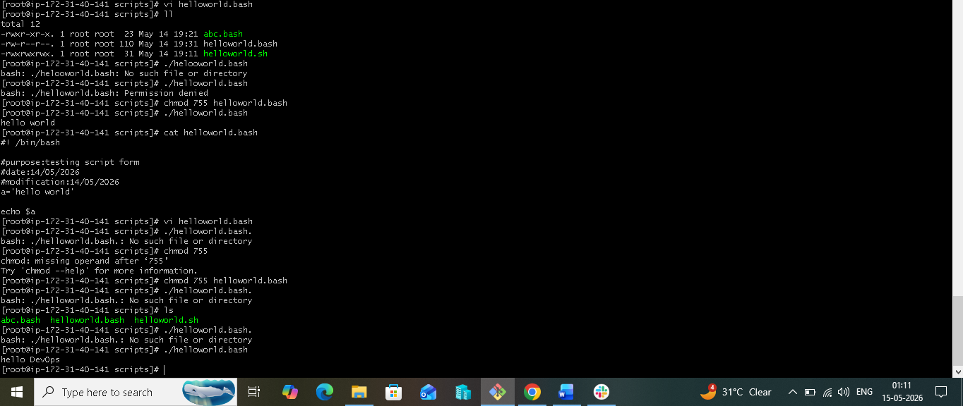

[root@ip-172-31-40-141 scripts]# cat test
cat: test: No such file or directory
[root@ip-172-31-40-141 scripts]# ll
total 12
-rwxr-xr-x. 1 root root 23 May 14 19:21 abc.bash
-rwxr-xr-x. 1 root root 111 May 14 19:36 helloworld.bash
-rwxrwxrwx. 1 root root 31 May 14 19:11 helloworld.sh
[root@ip-172-31-40-141 scripts]# rm -rf *
[root@ip-172-31-40-141 scripts]# ls
[root@ip-172-31-40-141 scripts]# vi helooworld.bash
[root@ip-172-31-40-141 scripts]# ll
total 4
-rw-r--r--. 1 root root 104 May 14 19:52 helooworld.bash
[root@ip-172-31-40-141 scripts]# chmod 755 helloworld.bash
chmod: cannot access 'helloworld.bash': No such file or directory
[root@ip-172-31-40-141 scripts]# ls
helooworld.bash
[root@ip-172-31-40-141 scripts]# mv helooworld.bash helloworld.bash
[root@ip-172-31-40-141 scripts]# ls
helloworld.bash
[root@ip-172-31-40-141 scripts]# chmod 755 helloworld.bash
[root@ip-172-31-40-141 scripts]# ./helloworld.bash
hello world
[root@ip-172-31-40-141 scripts]# vi helloworld.bash
[root@ip-172-31-40-141 scripts]# ./helloworld.bash

hello world
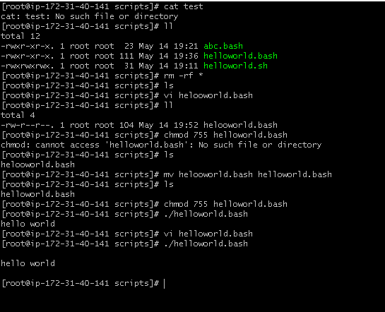
[root@ip-172-31-40-141 scripts]# vi commands.bash
[root@ip-172-31-40-141 scripts]# chmod 755 commands.bash.
chmod: cannot access 'commands.bash.': No such file or directory
[root@ip-172-31-40-141 scripts]# chmod 755 commands.bash
[root@ip-172-31-40-141 scripts]# ll
total 8
-rwxr-xr-x. 1 root root 49 May 14 20:00 commands.bash
-rwxr-xr-x. 1 root root 114 May 14 19:55 helloworld.bash
[root@ip-172-31-40-141 scripts]# ./commands.bash
/salman/scripts
commands.bash helloworld.bash
root
[root@ip-172-31-40-141 scripts]# cat commands.bash
#! /bin/bash

pwd
ls
whoami
date
cal
touch a b c
[root@ip-172-31-40-141 scripts]# vi commands.bash
[root@ip-172-31-40-141 scripts]# ./commands.bash
./commands.bash: line 3: pwdi: command not found
/salman/scripts
a b c commands.bash helloworld.bash
root
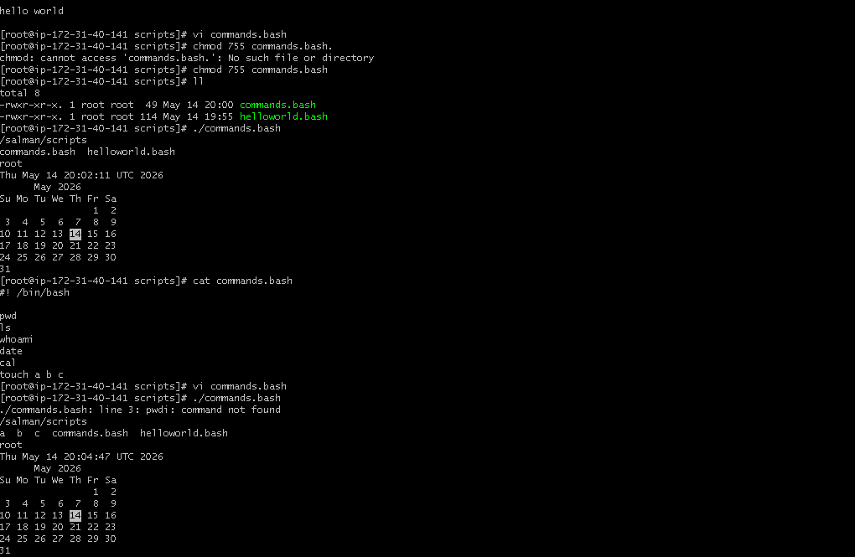

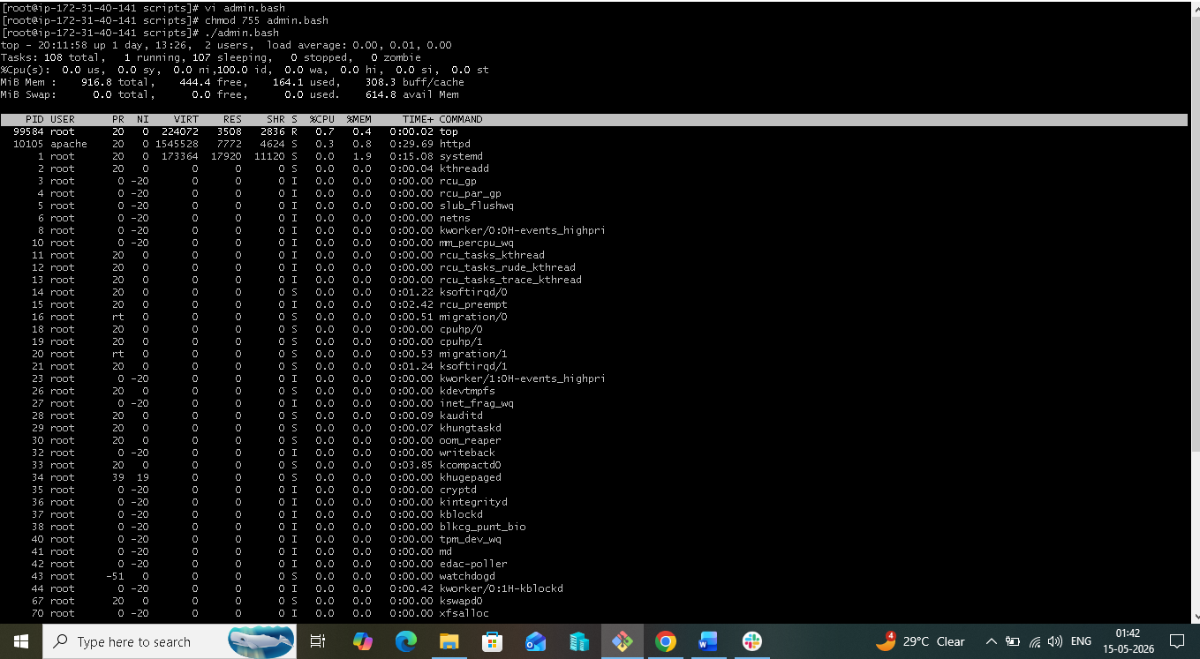
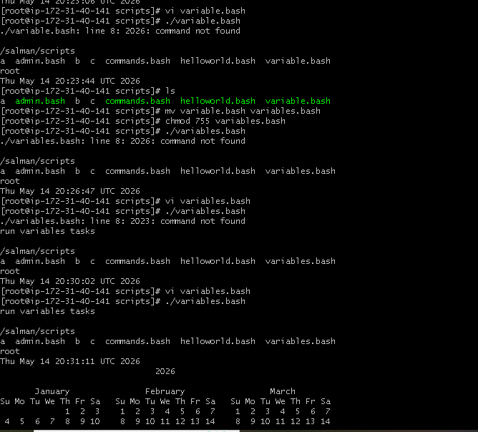

[root@ip-172-31-40-141 scripts]# vi input.bash
[root@ip-172-31-40-141 scripts]# cat input.bash
#! /bin/bash
echo Hello, my name is salman
echo
echo what is your name?
read name
echo
echo Hello $name
echo
[root@ip-172-31-40-141 scripts]# chmod 755 input.bash
[root@ip-172-31-40-141 scripts]# /.input.bash
bash: /.input.bash: No such file or directory
[root@ip-172-31-40-141 scripts]# ls
a admin.bash b c commands.bash helloworld.bash input.bash variables.bash
[root@ip-172-31-40-141 scripts]# ./input.bash
Hello, my name is salman

what is your name?
sallu

Hello sallu
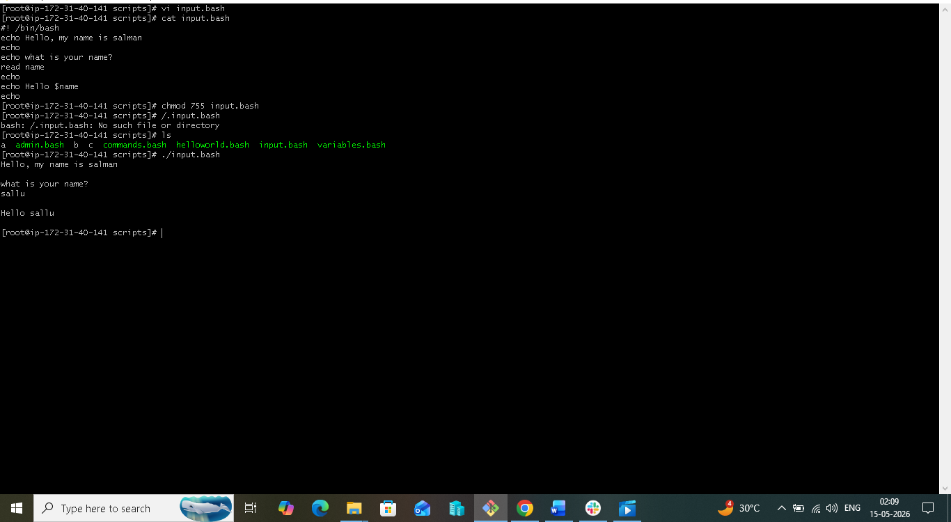

[root@ip-172-31-40-141 scripts]# vi output.sh
[root@ip-172-31-40-141 scripts]# ./output.sh
Hello,my name is ip-172-31-40-141.ec2.internal

what is your name?
salman
hello salman

[root@ip-172-31-40-141 scripts]# vi output.sh
[root@ip-172-31-40-141 scripts]# ./output.sh
Hello,my name is ip-172-31-40-141.ec2.internal

what is your name?
salman
hello salman

hostname
